

Mobile Phone and Digital Devices Policy

Mobile Phone and Digital Devices Policy

This policy applies to the Prep School and the Senior School

We recognise that mobile phones and digital devices have become an integral part of life. We recognise that there are educational, organisational and recreational value through the use of mobile phones and digital devices. However, it is important to recognise that to maximise the benefits of phones and digital devices, we as adults must role model and teach the safe, responsible and considered use of mobile phones and digital devices to young people.

Ipswich High School (IHS) has clear rules and guidelines to help develop good learning habits and prevent any disruption at school, as outlined by the DFE. We aim to educate pupils in the responsible use of technology.

DFE Guidance: https://assets.publishing.service.gov.uk/media/65cf5f2a4239310011b7b916/Mobile_phones_in_schools_guidance.pdf

Pupils are permitted to bring mobile phones to school, however there are clear procedures in place to prevent any use during the day when there is not permission from a member of staff. Please see the following expectations for each school stage.

Prep School:

Pupils in the Prep School may not use mobile phones at any time during the school day, unless permission from a member of staff is granted in exceptional circumstances. Any pupil in the Prep School having a phone, can only do so through parents informing the Head of Prep in writing. A clear record of who has permission will be kept. During the school day, mobile phones must be switched off and stored in Prep Reception. Any pupils not following this guidance, will be considered not to be respecting the schools expectations, therefore the school behaviour policy will be followed.

Year 7 Pupils

Pupils in Year 7 from September 2025, will place their mobile phone, should they have one, in a lockable pouch. Each Year 7 pupil will be issued a pouch provided by the school. Replacement pouches if lost or damaged can be purchased from the school for £15. Pouches are signal blocking.

As part of morning tutor time routine, pupils will routinely take out their mobile phone, should they have one, place their phone in their pouch, and lock the pouch shut so that their tutor can see this done.

At the end of the day, unlocking stations will be opened so that pupils can open their pouch and access their phone.

If a pupil requires their phone for prep or within a lesson for learning, the teacher will be able to unlock pouches at their discretion, as they will have access to an unlocking unit. There will be provision in place for pupils without a phone or digital device to be able to access their prep information, if they are doing a prep session.

This approach will be reviewed at the end of Term 1, 2025.

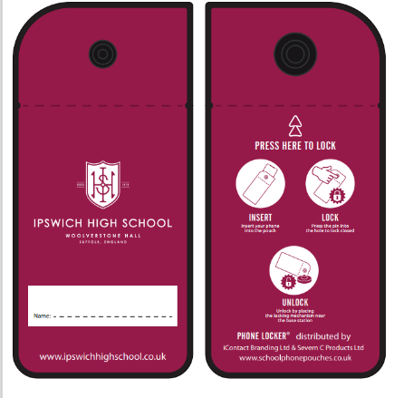
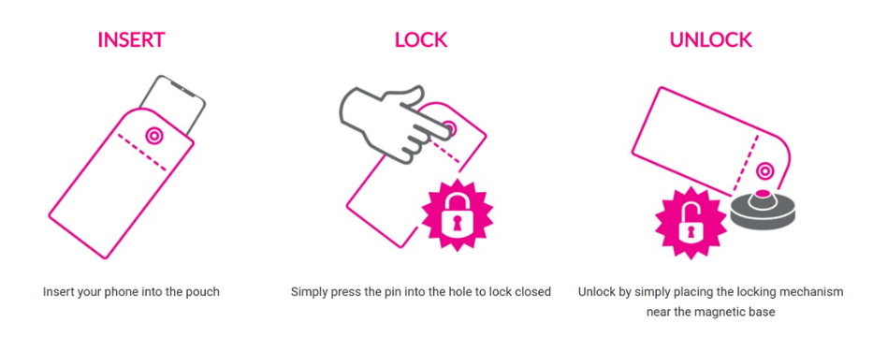

Year 8 – 11 pupils:

Pupils in Year 8 to Year 11 may not use mobile phones at any time during the school day unless permission from a member of staff is granted.

As part of morning tutor time routine, pupils will routinely take their mobile phones out and ensure they are switched off and stored safely. However, if and when appropriate, an individual member of staff may give permission for the use of a phone for a specific learning purpose.

Y12 – Y13 pupils:

Year 12 and 13 students may use their phones in the Sixth Form area, as long as this is not in a manner or place that is disruptive to others or to the normal routine of the school.

We expect Sixth Form pupils to embrace that they are role models to younger pupils and have good self-discipline in their own use of mobile phones. It is not acceptable for a Sixth Former to be carrying their mobile phone in their hand or clearly visible on their person when navigating school. Sixth Formers must not use their phones around school, in the Orwell Kitchen or Orangery.

This will be monitored by staff and reviewed by the Heads of Sixth Form and Senior Leadership Team.

Rules and responsible use of mobile phones

  - Courtesy, consideration and respect for others are paramount at all times.
  - Please note that it is a criminal offence to use a mobile phone to menace, harass or offend another person (almost all calls, text messages and emails can be traced).
  - Cyber-bullying is unacceptable and will be followed up by the school as serious misbehaviour concern in accordance with the Anti-Bullying and Behaviour Policy
  - Pupils should not use vulgar, derogatory or obscene language while using a mobile phone for either phone calls or messaging.
  - Pupils must ensure that files stored on their phones do not contain violent, degrading or offensive images. The transmission of some images/information can be a criminal offence and would be dealt with as such by the school.
  - Pupils must not use phones or any device to broadcast music, transfer inappropriate material or illegally share copyrighted material.
  - Pupils should not, on any account, use their mobile phone or device to photograph or video any member of the school community without their consent.
  - Mobile phones or other electronic devices must not, under any circumstances, be taken into examination rooms. Breach of this rule will lead to invalidation of that examination and possibly other examinations.
  - Mobile phones are not permitted in the EYFS classes.
  - Responsibility for the phone rests with the pupil and the school accepts no financial responsibility for damage, loss or theft. It is, therefore, recommended that phones are named/labelled for easy identity. (Any mobile phone found ‘lost’ in school should be handed in at Senior or Prep reception.
These expectations also apply to the use of mobile phones during school trips, travelling to and from school trips, extra-curricular activities or other off-site supervised activities. Pupils should keep their phones switched off and in their bags. They may only be used if permission is given by the member of staff in charge of the trip. Usual school sanctions will apply if a phone is used without permission during these times.

Note: The term ‘phone’ in this policy includes mobile phones, iPods, MP3, MP4 players, e-readers, smart watches, headphones and any similar portable electronic devices.

Communication with home

If there is an emergency which requires communication with home, pupils should speak to a member of staff who will help them. Pupils will be able to use the school reception phone to call home if necessary. If a pupil falls ill during the course of the school day, the School Nurse will contact parents/guardians. If unwell, pupils must not contact parents to ask to be collected – the School Nurse will make contact.

If a parent needs to contact their child, for instance in an emergency, they should phone the school reception for a message to be passed on to the pupil, rather than trying to contact their child directly on their mobile phone. This will ensure that a pupil is given support and privacy dealing with any potentially difficult situation.

If an after-school fixture is cancelled on the day, parents will receive a message via Evolve.

Devices and mobile phones in boarding

- Boarders are permitted to have electronic devices if used appropriately as outlined in this policy.
- Devices play a pivotal role in allowing pupils to keep in touch with family members.
- Boarders for years 7-11 are required to hand all electronic devices in prior to bedtime. Devices are stored securely overnight.
- We strongly believe as a school that good sleep hygiene and bedtime routines play a vital role in ensuring pupils are well rested to succeed and be happy every day.
- Year 12 and 13 pupils will be monitored carefully to ensure they use their devices are not used overnight.

Likely consequences for inappropriate use of mobile phones

- If a device is used during the school day inappropriately, it will be confiscated and handed into reception, where the pupil can collect it at the end of the school day.
- If a pupil damages or loses their pouch, a £15 replacement will need to be purchased.
- Staff will log confiscation as a logical consequence.
- Multiple breaches of this policy will lead to the relevant HOY or Boarding Staff member reviewing a longer-term confiscation or the possibility of permanent confiscation during school time.

Prep School Consequence

  - If a pupil is found using a mobile phone in school, it will be confiscated and will need to be collected from the Head Prep School at the end of the school day. Inappropriate behaviour regarding mobile use will be dealt with in accordance with this policy and our school behaviour policy.

Advice and links for parents and pupils on the safe use of mobile phones

  - It is recommended that children under 14 do not have access to the internet unsupervised and should not use chat rooms or become members of social networks.
  - Do not give out your number or friends’ numbers to people you don’t know, including in Instant Messenger or social media sites.
  - Do not call or text numbers which are not familiar to you.
  - It is strongly advised that you use passwords/pin numbers to ensure that unauthorised phone calls/messages cannot be made on your phone (e.g. by your friends, or if stolen).
  - You must keep your password/pin confidential. Mobile phones and/or passwords should not be shared.
  - If you receive texts which upset you, do not reply but keep a record and tell a trusted adult. In serious cases you can report it to the police.
  - If you receive a rude or embarrassing image or text about someone, don’t forward it to others, tell an adult.
  - Distributing sexual images of other young people is classed as harassment and is illegal. If you receive something like this, tell a trusted adult immediately.
  - Ask permission before taking a picture of your friends and think before sending it on. Once sent you have lost control of it and it could become public before you know it.
  - Visit the Thinkuknow website at www.thinkuknow.co.uk for more information on staying safe.
Age Restrictions for mobile phone apps (please note, currently WhatsApp have reduced their restriction to 13 as of April 2024)

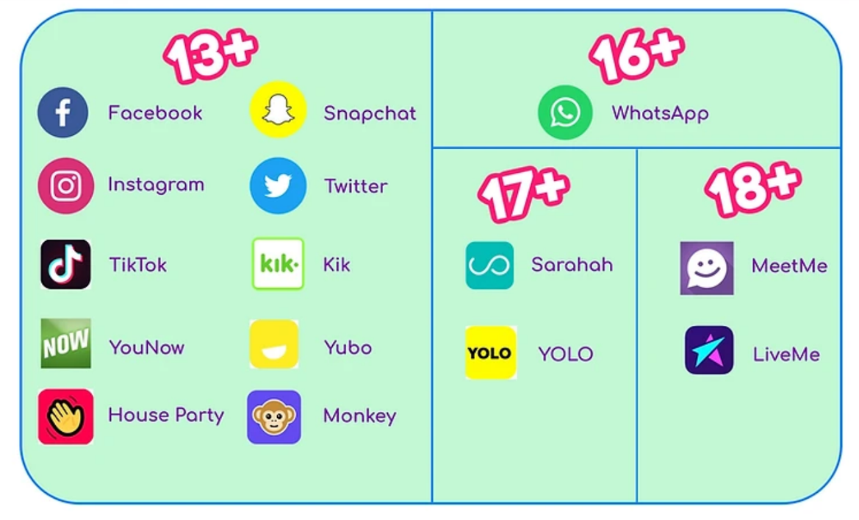

References for pupils and parents

Mobile phones in schools - February 2024

Jonathan's Parent & Teacher Talk | The Anxious Generation

https://www.anxiousgeneration.com/

The Anxious Generation Out Now. Order the Book.

https://saferinternet.org.uk/

https://www.ceopeducation.co.uk/

Policy created by Director of Boarding and Pastoral Care (July 2025)

